**Experiment 9**

Name: Ravish Dagar

Sap-500061767

Roll No-96

* Aim- Design a mountain landscape on blender.
* Procedure-

1. Open a new blender file.
2. Add a new mesh landscape.
3. Design and alter the shape of the mountain accordingly.
4. Give the color to the mountains.

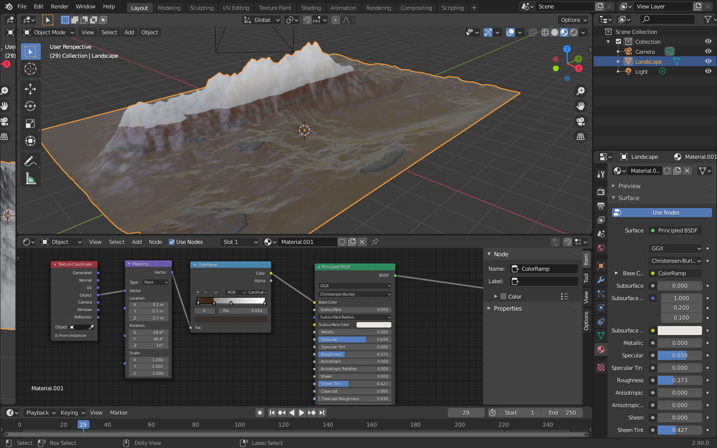

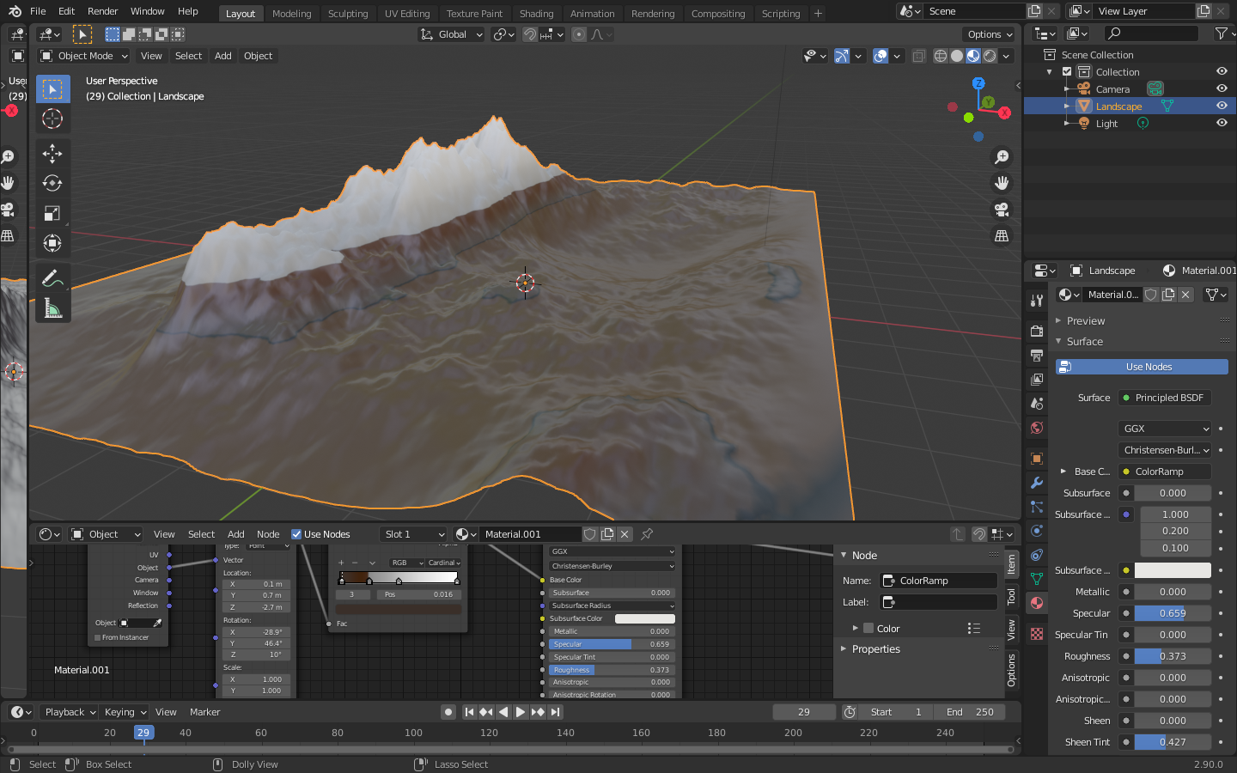

1. Select the portion of the area aside mountain and assign it as water and give blue color to it.

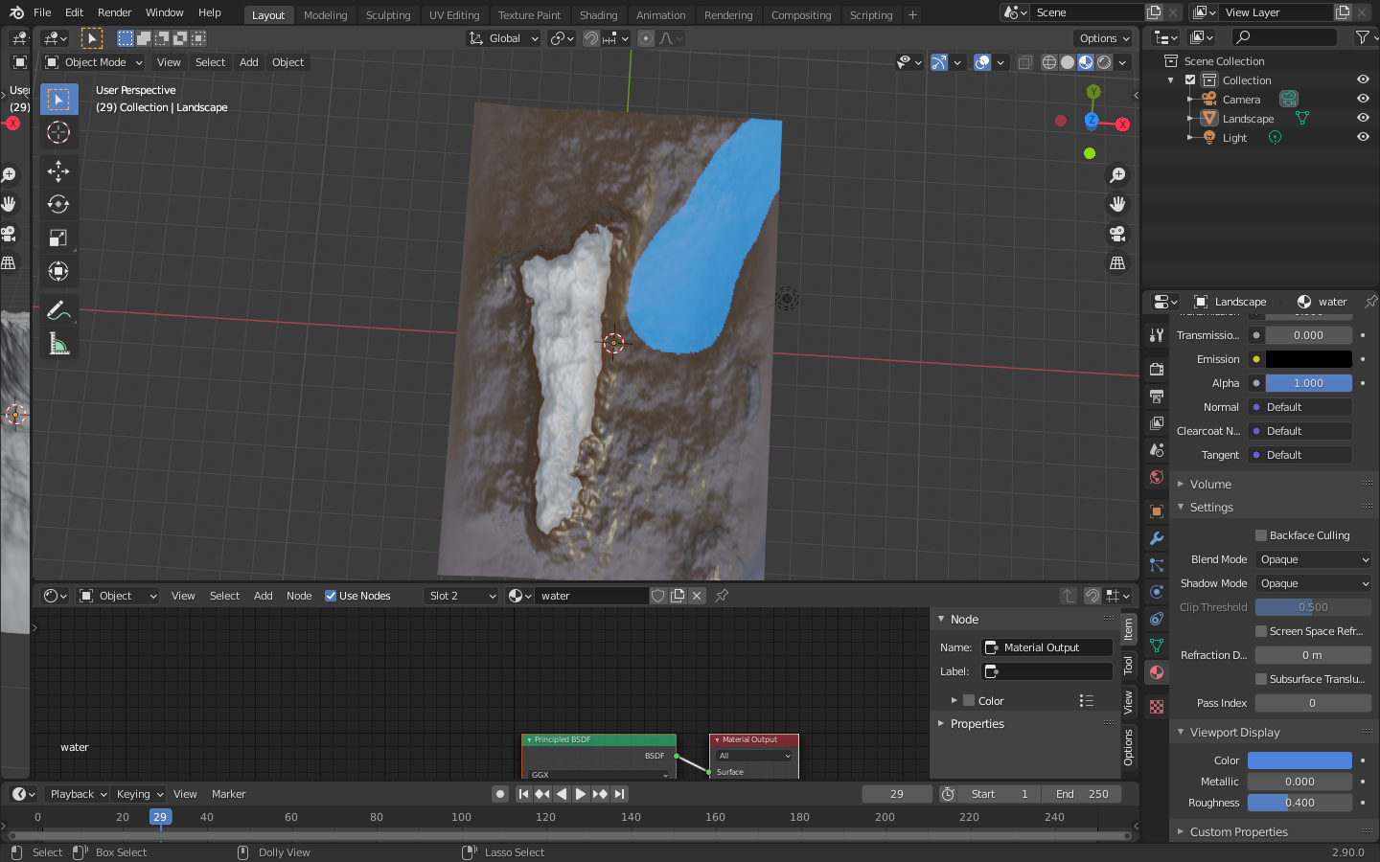

1. Hence, mountain landscape is completed.

